Provider Information Form | 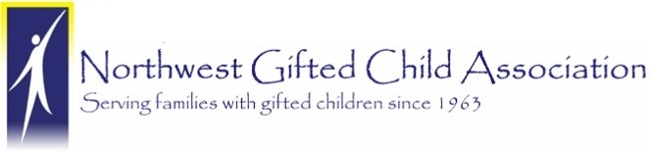

Contact Information
Name
E-mail Address
Work Phone
Website
WA Provider License No.

Service(s) Provided
Medical Professional, please specify:
Counseling/Therapy
Educational Testing/Assessment
Occupational Therapy
Physical Therapy
Consulting/Coaching
Tutoring
Other, please specify:

Do you have experience working with gifted individuals? Do you typically work with children, teens, adults, and/or families?

Do you have a specialty or preferred area of expertise? Do you have additional certifications or training that may be of interest to families with gifted children?

Have you worked with twice-exceptional children/teens and their families?

Briefly state how your understanding of the needs of gifted/2e individuals and families inform your approach?

Please list any professional organizations in which you are affiliated.

About NWGCA
The Northwest Gifted Child Association (NWGCA) is a support and advocacy organization for parents of gifted children. Organized in 1963, NWGCA provides support and information to parents of gifted children. It continues to help parents enhance and hone their parenting skills and gives them tools to speak out for an appropriate gifted education and deal with this learning difference we call giftedness. NWGCA works with individual families, talking with them by phone and through emails, providing appropriate referrals and resources through our website. Thank you for completing this application form and for supporting the gifted and talented families of Washington State. Please email completed form to info@nwgca.org.

